**Beneficiar file: Children’s Palace “House Cantacuzino-Pașcanu” Iași**

**Description**

Children's Palace activity implies a specific instructive-educational approach, through which the children increases their knowledge from different domains, facilitating the development and exercise of skills according to the vocation and option of the children.

The Palace is an institution of education which organises non-formal training activities divided in 3 categories: laboratories, workshops and clubs.

The activities can be organised together with educational institutions, ONGs and other profile institutions.

**Mission**

Children’s Palace mission is to offer a favorable environment for performance by organizing activities of great extent, bringing the young on the city’s scenes, in art galleries and in workshops.

**Activity profile**

Education and other theatrical activities (creation, artistic interpretation and literature)

The Palace hosts its activity in around 100 clubs divided in 6 domains:

1. visual arts;
2. art
3. civic culture
4. technical and scientific
5. technical applications
6. sports and tourism

**Examples of activities**

* Traditional musical instruments
* Legal Environment of Business Transactions
* History of Rock and Roll
* Principles of Management

**Recent events**

* National Contest “My intercultural journey”
* Dragobete, XIII Edition
* “IA ȘI green bag!”

**Number of employees: 107 pers**

* Teaching staff
  + Director - 2 pers.
  + Teachers - 85 pers.
* Auxiliary teaching staff
  + Coach - 3 pers.
  + Financial Administrator - 1 pers.
  + Secretary - 2 pers.
  + Asset Administrator - 1 pers.
  + Accompanist - 1 pers.
* Non-teaching staff
  + Administrator - 1 pers.
  + Worker - 2 pers.
  + Watchman - 5 pers.
  + Janitors - 3 pers.
  + Driver - 1 pers.

**Structure of the lot**

* Main building
* Secondary building
* Recreational space
* Green space
* Parking lot

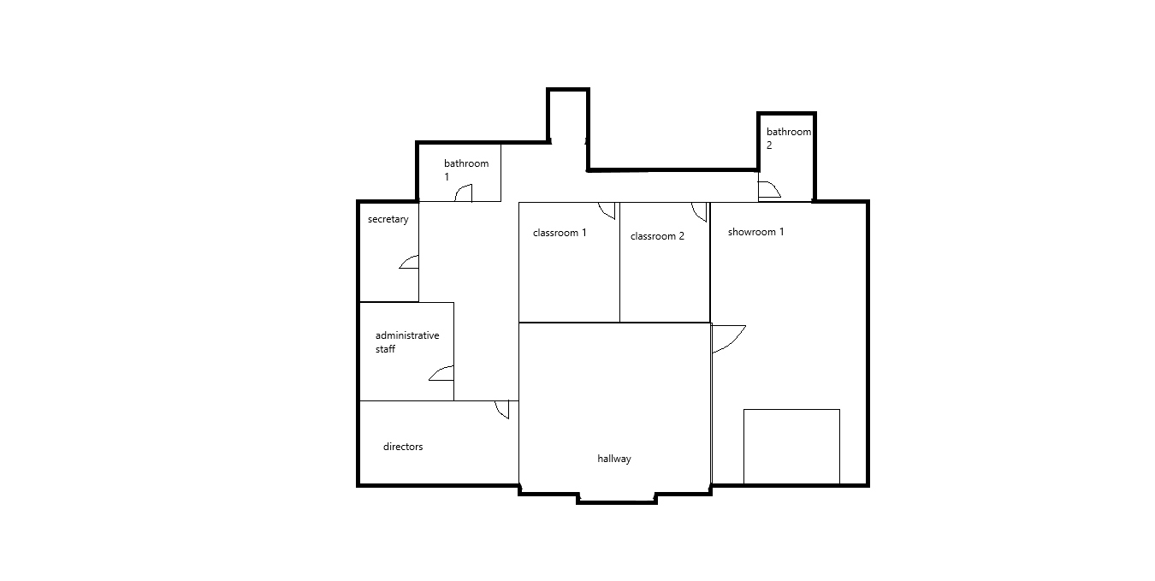

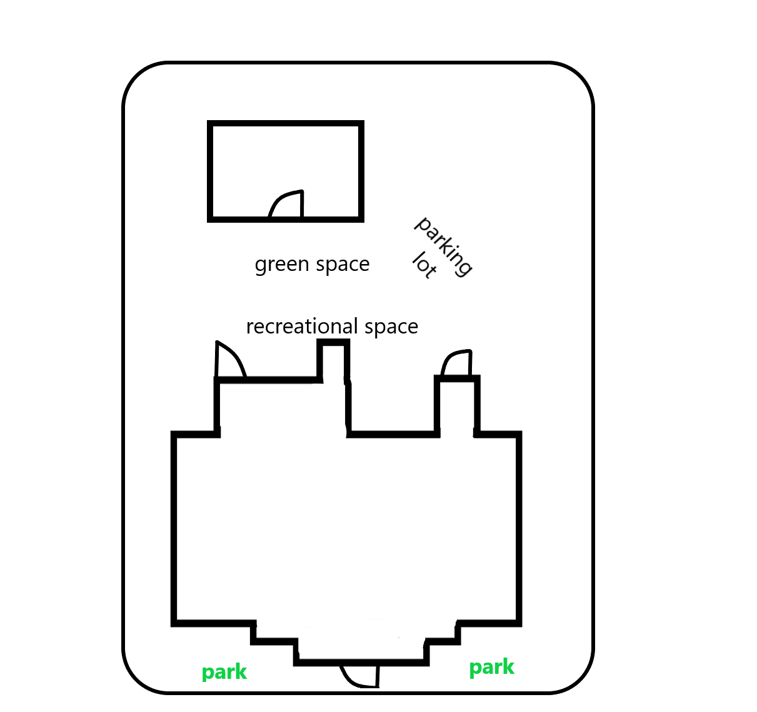

**The organizational structure**

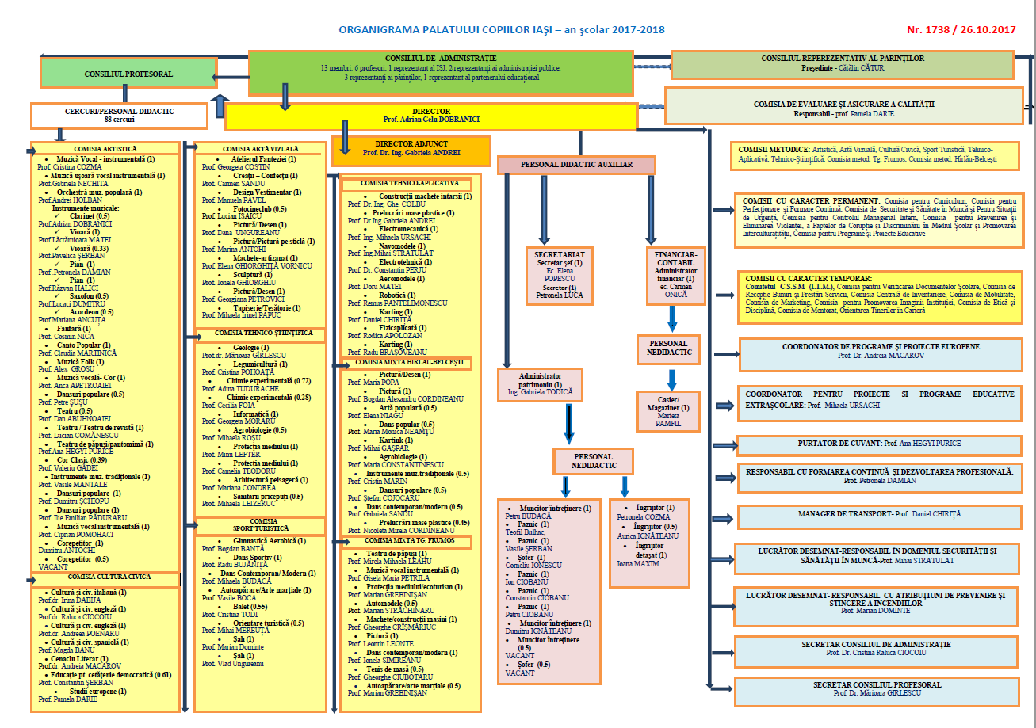

**Future plans (for the next 5 years)**

Increasing their staff number by 50 more people, having in total 157 staff members, and extending their activities in a new building as big as the actual one, or bigger, in the city of Iasi.

**Group 5311 & Names:**

Beatrice Calugareanu

Dragos Vacalie